Description of tasks | 180214 | Remco de Koning

# General

The general purpose of this project is to automate the process of analysis on urban environments that promotes informed decision-making for planners. The main tasks are to quantify, manipulate, aggregate and visualise the data. Subsequently, calculations need to be made that can inform us what type of planning strategy to apply in a specific location based on the results of the analyses.

Three analysis methods are used. First, the Space Syntax method is used to make calculations on the street network configuration. Second, the Spacematrix method quantifies building densities and building typologies. Third, the degree of functional mix is quantified using the Mixed-Use Index method. This document describes the first part: data preparation.

# Tasks

## Street network configuration

How well or poorly a street is integrated in the street network is calculated with the Space Syntax method in the program Depthmap. Axial lines representing lines of sight are supplied as two shapefiles. The Axmap file contains the values: *Global Integration* and *Local Integration*. In the Segmap file, the values *Metric Step Depth High Radius* and *Metric Step Depth Low Radius* are provided. The following workflow needs to be automated (scripted):

1. Add new attribute columns for the four values mentioned above using the attribute names GI, LI, MH and ML;
2. Into these columns, categorise the integration values into *low*, *mid* and *high* values using the natural break method;
3. Make a new attribute column in which to aggregate these four values;
4. Aggregate the rounded-off values in the following manner: ((GI ∙ LI) + (MH ∙ ML));  
   > We now have a single shapefile that contains the four separate values and the aggregated, rounded-off values for every axial line.

## Building density

Building density and building typology can be quantified by three parameters*: Floor Space Index* (FSI), *Ground Space Index* (GSI) and *Open Space Ratio* (OSR). The calculations require floor space B ([BRUKSAREAL]) plot area A ([AREAL]) and number of floors L:

FSI = B / A

GSI = ((B / L) / A)

OSR = (1 - [GSI]) / FSI

1. Add four new attribute columns, call them [FSI], [GSI], [OSR] and [BLDCLASS]
2. Using the formulae above, obtain the values using [BRUKSAREAL], [AREAL] and [F_ETASJER]
3. Populate [BLDCLASS] and categorise according to the explanation in Table 1 (Ye *et al.*, 2016:78)

## Functional mix

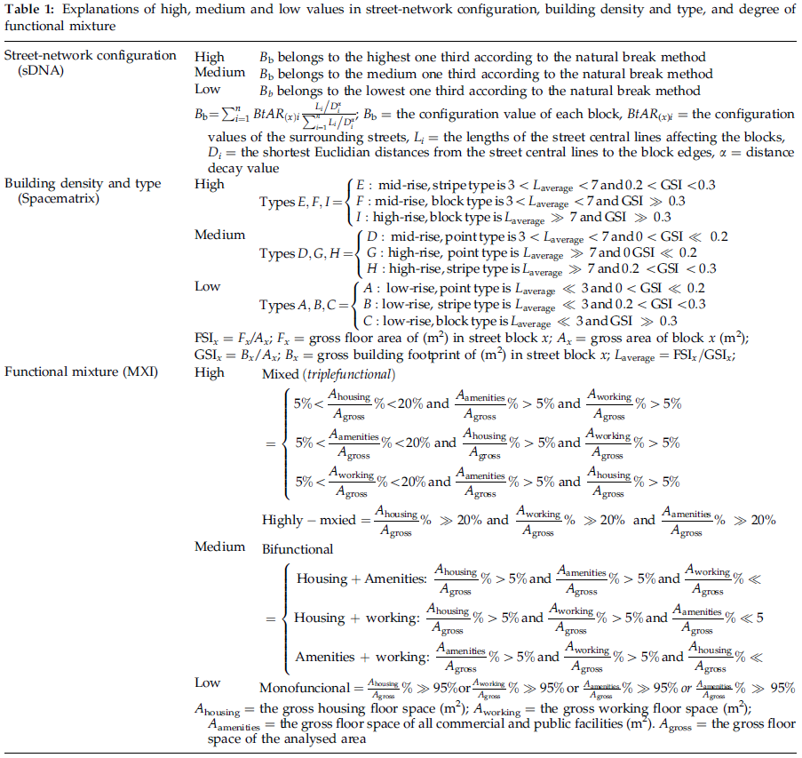

In the Bergen case, we can obtain the building function from the attribute data under [TYPEKODE].

1. To get these, please see my description under section 4.5 in the document *180202_Workflow_Arcmap.docx*.
2. With the attribute columns [AMENITIES], [OFFICES] and [HOUSING] now populated, make a new attribute column called [MXI].
3. Use the categorisation as explained in Table 1 to populate [MXI].

References

YE, Y., YEH, A., ZHUANG, Y., NES, A. V. & LIU, J. 2016. "Form Syntax" as a contribution to geodesign: A morphological tool for urbanity-making in urban design. *Urban Design International,* 22-1**,** 73-90.